**zoo, zoa zoa**

**ANIMALS**

[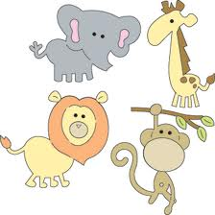](http://www.google.com/imgres?q=zoo+animals&um=1&sa=N&hl=en&biw=1440&bih=760&tbm=isch&tbnid=hl_dFRQfG8hVnM:&imgrefurl=http://www.provocraft.com/products/detail.php?cl=cuttlebug&scl=dies&cat=&item=37-1200&docid=Ru7au6ayXr1lWM&imgurl=http://content.provocraft.com/d/images/products/cuttlebug/product/large/37-1200.jpg&w=550&h=550&ei=EFyRUaSANubE4APT0IGACg&zoom=1&ved=1t:3588,r:18,s:0,i:216&iact=rc&dur=2257&page=1&tbnh=182&tbnw=182&start=0&ndsp=19&tx=101&ty=103)